NEW – 2019 20’ Eastern Center Console WITH T-top & Mercury 90HP CT - $57,500

NEW Boat for sale nORTHLAND BOAT SHOP - NORTH HERO, vt

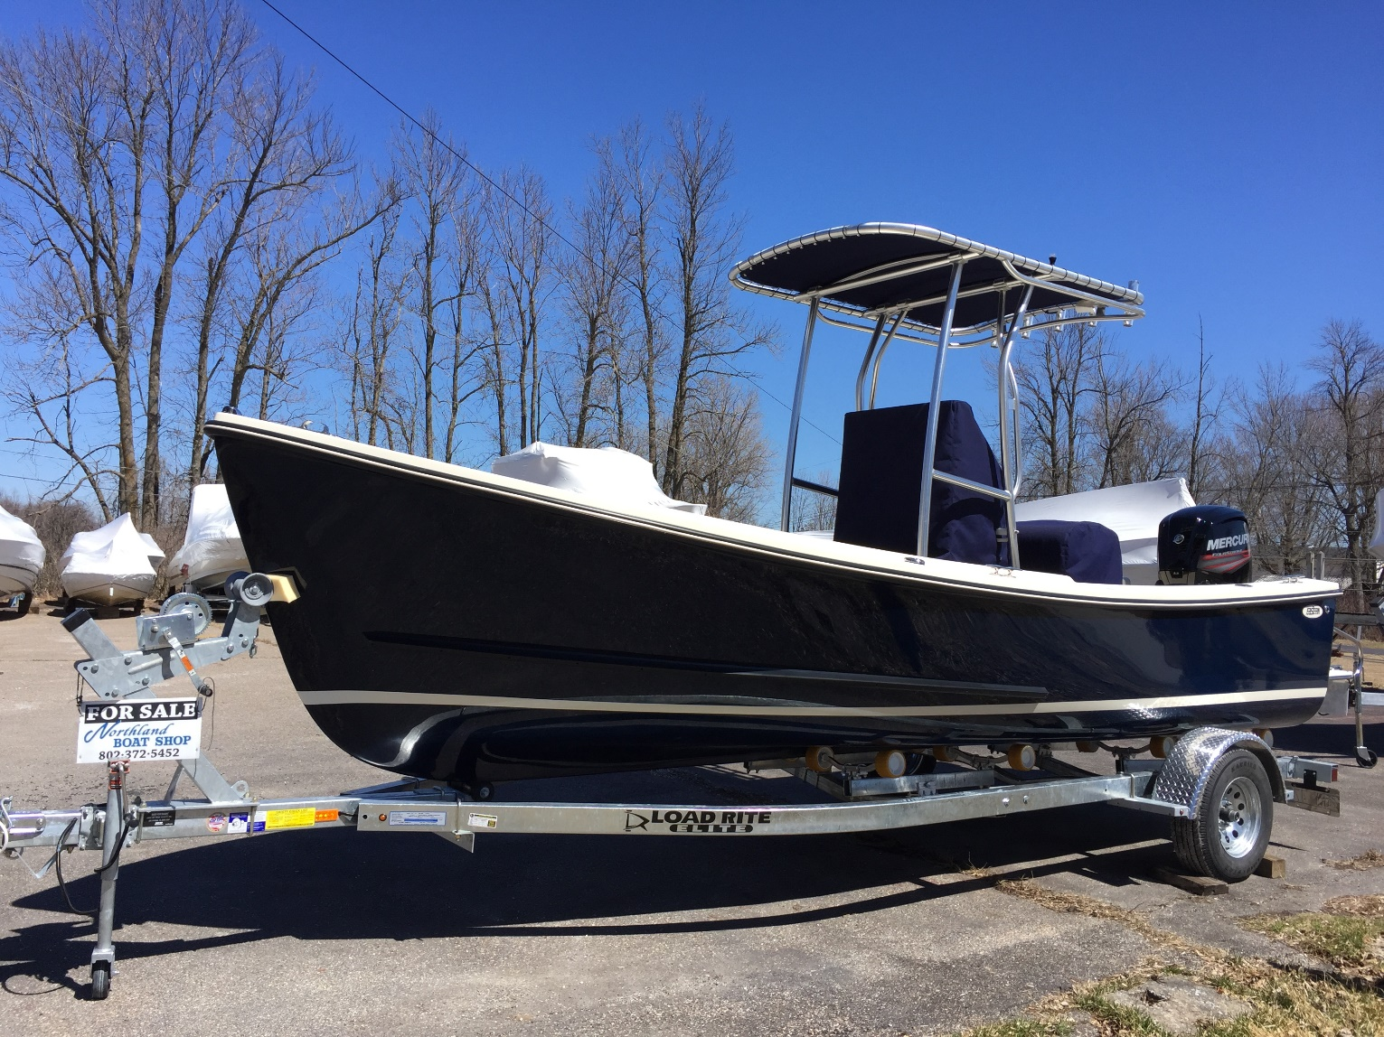
Make/Model: 20’ Eastern Center Console with T-Top, Eastern Boats, Milton, NH
Year: 2019
Length: 20’20” Beam: 7’6”
Location: Northland Boat Shop, North Hero, VT
Motor: 2019 Mercury 90HP Command Thrust
Price: $57,500
What a beauty! A classic center console with elegant downeast-style sweeping sheerline, this boat has a comfortable, safe ride with plenty of room forward and seating for 4-6. With a sharp entry at the bow parting the sea and a soft chine flattening from midships aft, these boats are designed to provide a smooth, level ride level at any speed. This “downeast advantage” allows these boats to run efficiently at a wide range of cruising speeds, from the low teens to the mid 20’s, burning from 2 to 4.5 gallons per hour, with top speeds of more than 35mph.

Contact Emily at Northland Boat Shop, 802-372-5452 w, 802-316-6721 m, sales.nlboat@gmail.com

